**iOS Application Testing Documentation**

* **Configuration of Burp Suite with iOS device:**
* Firstly, open the Burp Suite Application and go into the proxy tab. In the proxy tab go to the options and click on the Add.
* Now Add a new proxy, in the Bind to port options enter any port no. that not currently running by another application. I put it port no 8081.
* And in the Bind to address options select All interfaces options, then save/ok.

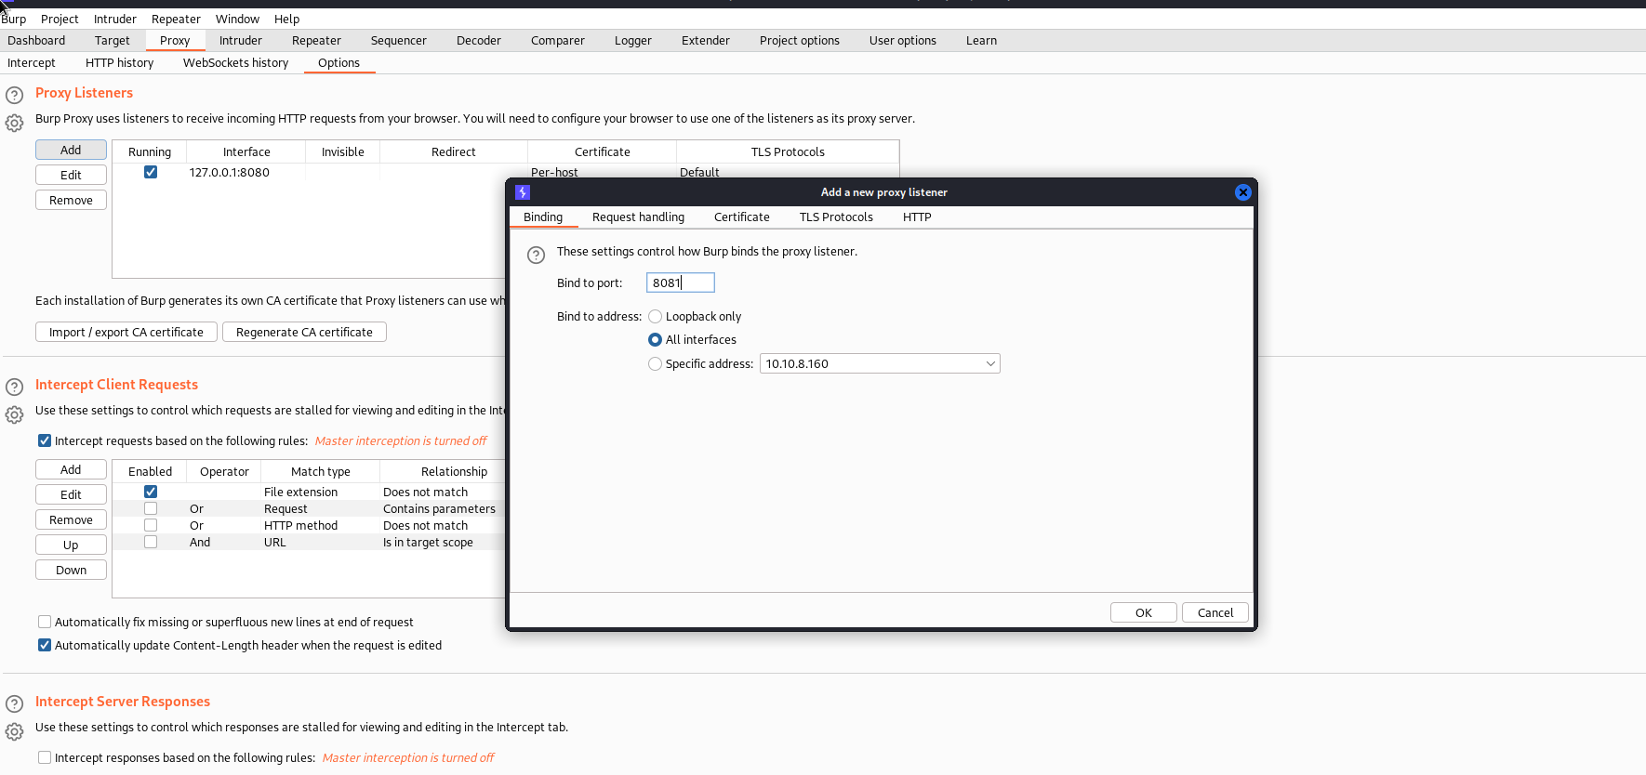

Now we need to set some settings in the iOS device.

* In the iOS devices open setting of the phone.
* Go into the Wi-Fi option, make sure that both devices (Attacking machine and iOS device connected with the same network).
* Then go to the configure proxy option and click on the Manual option and set here.
* You can see in the below images.

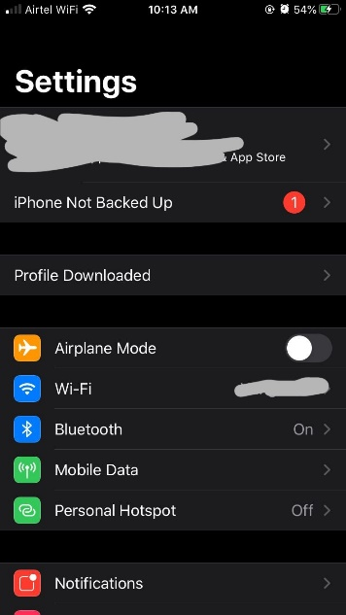 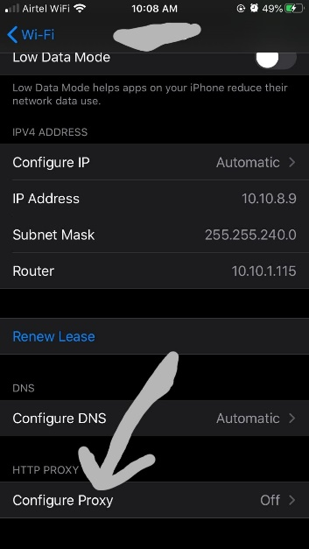 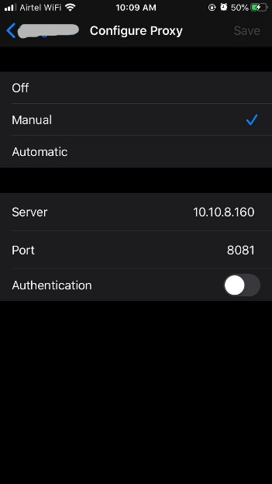

* Now the burp suite is configured with the iOS device. Now we need to add burp certificate in the iOS device for intercept the https request in the burp.
* For the add the certificate, firstly we need to download it.
* Turn on your burp intercept proxy and go to the safari browser in the iOS device.
* And search [**http://burp**](http://burp) click on the CA certificate, then allow it for the download.
* Now the certificate is download you can check it in your setting home page there is a profile download option become after download it. Go into the Profile Download option.

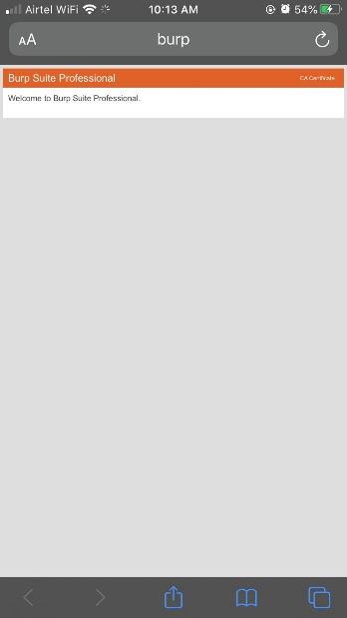 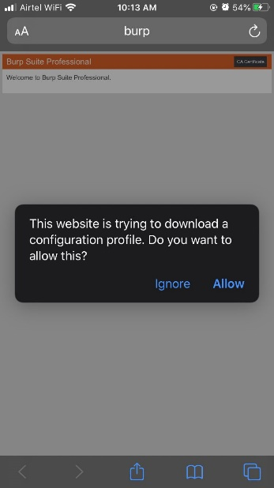 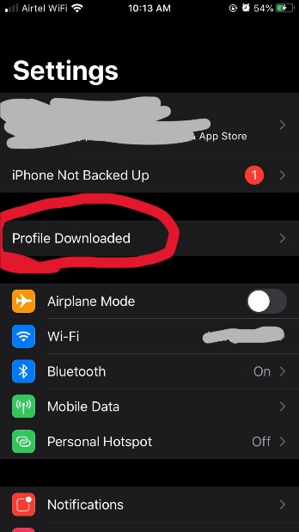

* And click on install button for install this certification in the device.
* Now the burp suite is completely configured with the iOS device.

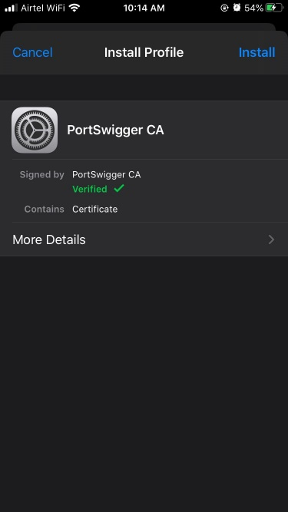

* For intercept the application request, turn on your intercept in the burp suite.

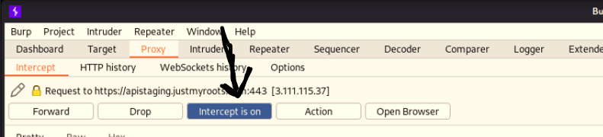

* Open any application and start the intercept the request of that application.

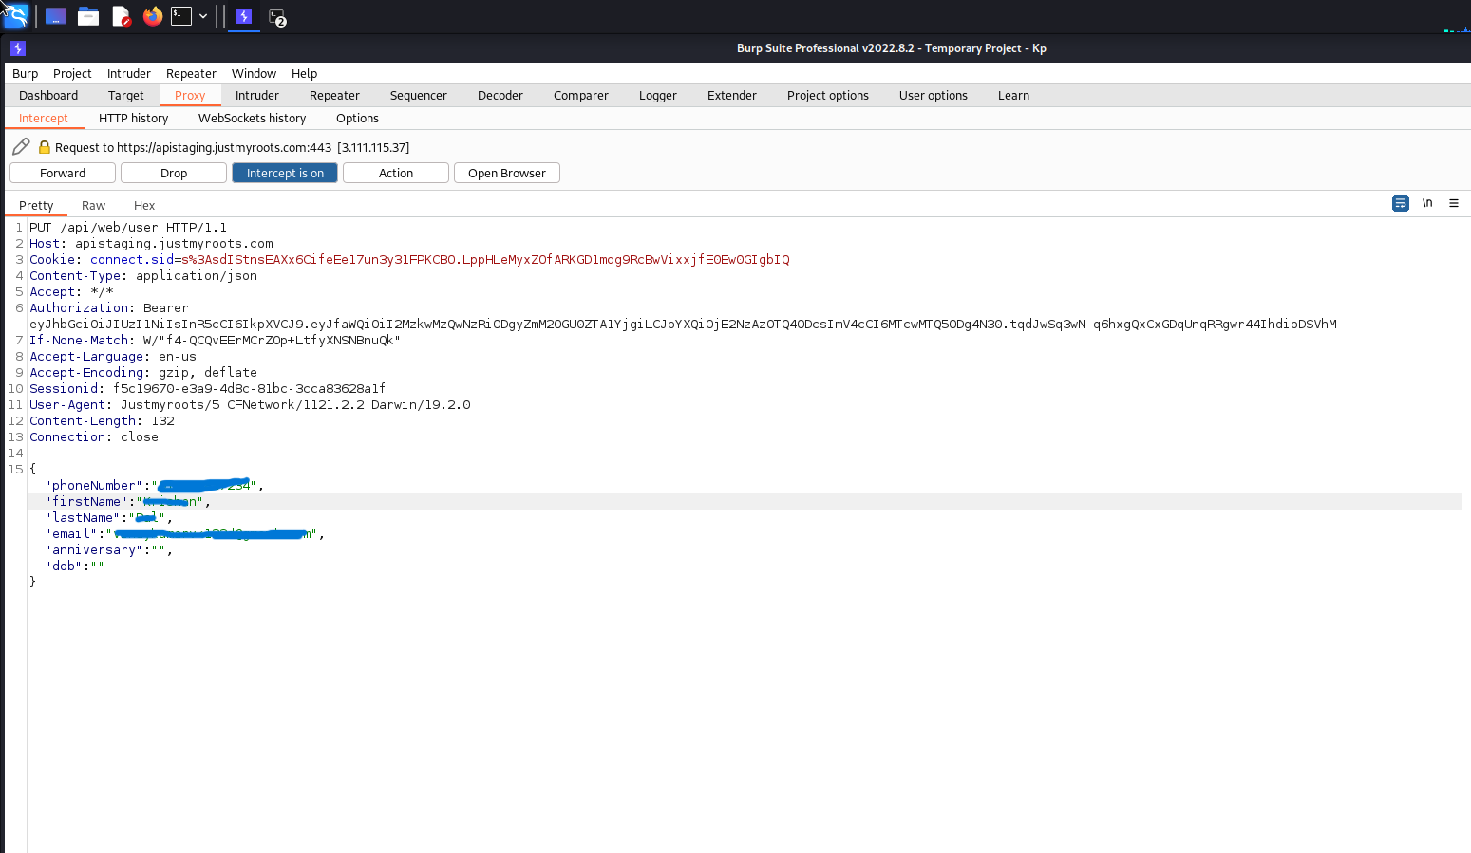

* **Testing through Frida and objection:**
* Installation of Frida and objection in Kali Linux
* Before Frida installation become a root user (**sudo su**)– run this command in the terminal **pip install frida-tools.**
* Same in the objection case firstly become root user then run this command – **pip install objection.**
* You can see in the below images.

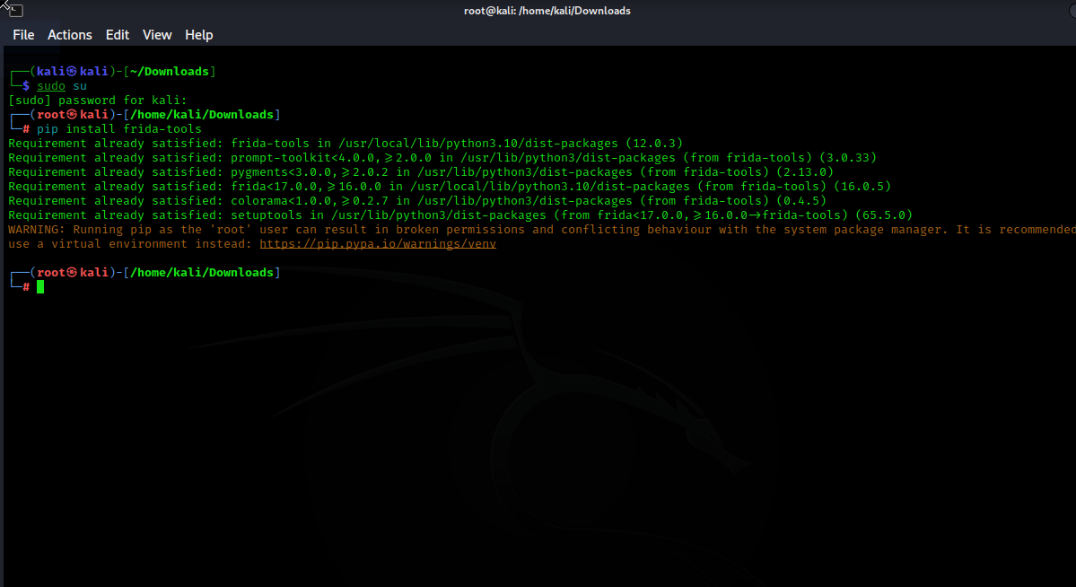

After installation of Frida and objection, we going to start testing.

* Connect you iOS device with linux.
* Run Frida command to show all the connected devices with kali.
* The command is - **Frida-ls-devices.**